**Muhammad Muneeb**

**Question no 1:**

Firstly I take inputs from user and then check for the email that is @ and . is present in it by check it in loop that if @ and . is not in email then it will take input again and also check that . will come after the @ by comparing their index

while "@" not in email or "." not in email or email.index("@") > email.index("."):

    print("email format is incorrect.")

    email =input("Enter your email: ")

then simple I store the data into Dictionary and in the result last message I simply show the values by getting it from dictionary by their keys

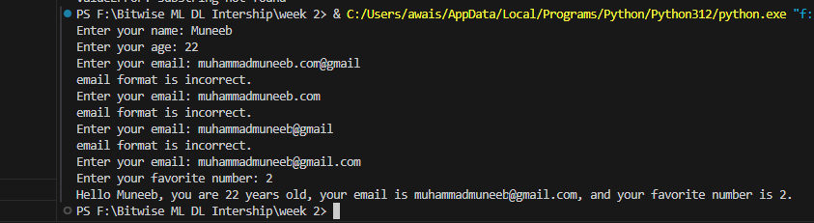

**Question no 2:**

In this question I simply takes the number from user as input and pass it as a Argument to the Function and then take the modulus of that number with 2 if it is equal to 0 that’s means it is multiple of 2 and a even number so in this case I return True else False  
  
 if number % 2 == 0:

        return True

    else:

        return False

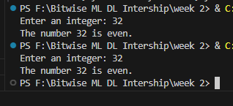

**Question no 3:**

First I take the temperature as Input and then I degree to which it has to be convert. So, for converting from Celsius to Fahrenheit use formal converted_temp = (temp * 9/5) + 32

And from Fahrenheit to Celsius  
converted_temp = (temp - 32) * 5/9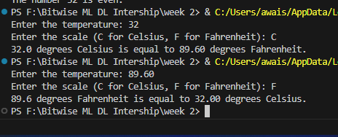

**Question no 4:**

Firstly I take the input from user and append it into the list then just by min and max function I get the maximum and minimum number

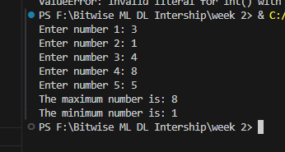

**Question no 5:**

First take the data of 3 students and store it in list as

 students.append((name, age, grade))

then convert it into dictionary from list as

  students_dict = {}

    for student in students_list:

        name, age, grade = student

        students_dict[name] = (age, grade)

and then simply Display it

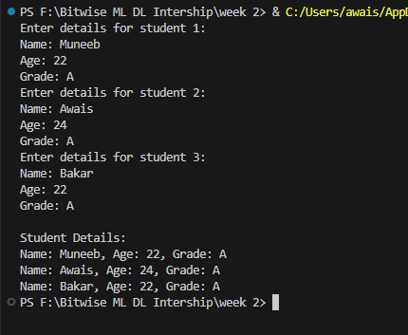

**Question no 6:**

First I take the initial inventory and then take item to update and then take operation + for adding and – for subtracting and then take quantity for + simply add the quantity and for – simply subtract the quantity. And then I check if the quantity is below 0 and assign it a 0

